DESIGN AND IMPLEMENTATION OF SMART SEWAGE SYSTEM

### A MINI PROJECT REPORT

***Submitted by***

|  |  |
| --- | --- |
| **HRITHIK VENUGOPAL** | **211420105308** |
| **JAYAKUMAR.KT** | **211420105309** |
| **AMARNATH.S** | **211420105302** |
| **RAJA NAVIN.R** | **211420105084** |

***in partial fulfillment for the award of the degree of***

## BACHELOR OF ENGINEERING

**in**

## No photo description available.ELECTRICAL AND ELECTRONICS ENGINEERING

PANIMALAR ENGINEERING COLLEGE

(An Autonomous Institution, Affiliated to Anna University, Chennai) APRIL 2023

PANIMALAR ENGINEERING COLLEGE

(An Autonomous Institution, Affiliated to Anna University, Chennai)

## BONAFIDE CERTIFICATE

Certified that this project report “**DESIGN AND IMPLEMENTATION OF IOT BASED SMART SEWAGE SYSTEM”** is the bonafide work of **“HRITHIK VENUGOPAL (211420105308), JAYAKUMAR.KT (211420105309), AMARNATH.S (211420105302), RAJA NAVIN.R**

**(211420105084)** who carried out the project work under my supervision.

### Dr. S.SELVI, M.E, Ph.D. HEAD OF THE DEPARTMENT PROFESSOR

Department of Electrical and Electronics Engineering, Panimalar Engineering College, Chennai-600 123.

### Mr. R.SAKTHIVEL M.E., SUPERVISOR

**ASST PROFESSOR**

Department of Electrical and Electronics Engineering, Panimalar Engineering College, Chennai-600 123.

Submitted for sixth Semester Project Viva Voice held on at Panimalar Engineering College, Chennai**.**

**INTERNAL EXAMINER EXTERNAL EXAMINER**

## ACKNOWLEDGEMENT

We would like to express our sincere thanks to our respected Chairman and Chancellor, Sathyabama University **Dr. JEPPIAR M.A., B.L., Ph.D.,** for being in the vanguard of scientific progress in our college.

We would like to express our deep gratitude to our Beloved Secretary and Correspondent **Dr. P.CHINNADURAI M.A., Ph.D.**, for extending his never ending support to us.

We extend our sincere thanks to our Professor &amp; Head of the

Department, Electrical and Electronics Engineering, **Dr. S. SELVI**

**M.E, Ph.D .**and a heartfelt thanks to our Professor **Mr. R.SAKTHIVEL M.E.** for his timely guidance in technical front and for instilling immense confidence in us for completing our project successfully.

We also extend our thanks to All Staff Members of Electrical and

Electronics Engineering for their support and technical assistance. On

a personal note, we would like to express our heartfelt thanks to our beloved Parents and our Friends, for their help and wishes in successfully completing this project. Thanks to Almighty for giving

us the strength to do this project success.

## ABSTRACT

A Synopsis of in Fewer Words Workers who are responsible for maintaining the cleanliness of sewage and drain systems face special challenges with regard to their health and safety. The well-being of those employees in relation to their professional and personal lives necessitates the establishment of effective safety measures. The ultimate goal of this project is to create a PIC Micro-Controller system that can identify potentially explosive or harmful gas levels then immediately sound an alarm, also by pressing emergency button when the Sewer workers causing by toxic gas or level of the drainage water level increasing. Liquid petroleum gas, natural gas, propane, butane, methane, and other combustible gases are a common cause of accidents. Sewer workers are particularly vulnerable to the lack of housing options and the toxic by product of waste water treatment, which account for a disproportionately high number of annual deaths. It would be beneficial to provide these workers with real-time monitoring and access to medical treatment. The device is a closed- loop health monitor for the canal that will collect data in real time. In addition, it can be programmed to release the window regulators if gas is detected escaping the vehicle. It provides internet access to real-time data that may be used with a gas detector to identify a variety of potentially harmful substances. In contrast to the mechanical methods that have been employed in the past, autonomous detection and notification systems can respond quickly and accurately in an emergency situation, which helps the news spread quickly.The level of toxicity of the sewage is indicated here using a cell phone sim .It will transmit the message to the receiver whether it is harmful or not; if it is more hazardous, it will transmit the message to the recipient.

**CONTENT**

|  |  |  |
| --- | --- | --- |
| CHAPTER NO | TITLE | PAGE NO |
|  | ABSTRACT | I |
| 1 | **INTRODUCTION** | 1 |
|  | * 1. Literature Survey   2. Existing System   3. Disadvantages Of Existing System | 2 |
| 4 |
| 5 |
| 2 | **PROPOSED SYSTEM** | 6 |
|  | 2.1 Advantages Of Proposed  System | 6 |
| 3 | **REQUIREMENTS** | 8 |
|  | **3.1 Hardware Requirements** | 8 |
| 3.1.1 Power Supply | 8 |
| 31.1.1 Block Diagram Of Power | 9 |
| Supply |  |
| 3.1.1.2 Circuit Description | 10 |
| 3.1.1.3 Circuit Diagram of Power | 11 |
| Supply |  |
| 3.1.1.4 Component List | 11 |
| 3.1.1.5 More Output Current | 11 |
| 3.1.2 Micro Controller | 12 |
| 3.1.2.1 Features of PIC Micro | 14 |
| Controller |  |
| 3.1.2.2 Peripheral Features | 14 |

|  |  |
| --- | --- |
| * + - 1. Analog features       2. Special Micro Controller Features       3. CMOS Technology       4. Pin Diagram       5. Device Overview       6. Memory Organization       7. Data Memory Organization       8. I/O Ports       9. Port A And the TRISA Register       10. Port B And The TRISB Register       11. Port C And The TRISC Register       12. Port D And The TRISD Register       13. Port E and TRISE Register     1. LCD 16x2        1. Product Description        2. Features     2. Temperature Sensor        1. Product Description        2. Features        3. Applications | 15  16  16  16  17  18  18  19  20  20  21  22  22  23  24  25  25  25  25  26 |

|  |  |  |
| --- | --- | --- |
|  | 3.1.5 Gas Sensor | 26 |
| 3.1.5.1 Product Description | 27 |
| 3.1.5.2 Features | 27 |
| 3.1.5.3 Applications | 28 |
| 3.1.6 GSM | 28 |
| 3.1.6.1 Product Description | 28 |
| 3.1.6.2 Features | 29 |
| 3.1.6.3 Applications | 30 |
| **3.2 Software Requirements** | 30 |
| 3.2.1 MP Lab IDE | 30 |
| 3.2.2 Embedded C | 31 |
| 4 | **RESULT AND DISCUSSION** | 32 |
| 5 | **CONCLUSION** | 34 |
| 6 | **FUTURE SCOPE** |  |

# LIST OF TABLES

|  |  |  |
| --- | --- | --- |
| 1 | 3.1 Port Function | 23 |

**LIST OF FIGURES**

|  |  |  |
| --- | --- | --- |
| 1  2  3  4  5  6  7  8  9  10  11  12 | Fig 2.1: Block Diagram  Fig 3.1: Power Supply Diagram Fig 3.2 : Circuit Diagram 1  Fig 3.3 : Circuit Diagram 2  Fig 3.4 : Pin Diagram  Fig 3.5: Program Memory Map And Stack Diagram  Fig 3.6 : 16x2 LCD Display Fig 3.7 : Temperature Sensor Fig 3.8 : Gas Sensor  Fig 3.9: GSM  Fig 4.1 : Kit Output  Fig 4.2 : Smart Sewage System GSM Notification | 7  8  11  12  16  19  24  26  27  29  32  33 |

# CHAPTER 1

INTRODUCTION

Several Indian cities have a subterranean sewage system that is managed by the Municipality to maintain a clean environment and safe for residents. Because of routine poop maintenance, the waste water in the drainage network is frequently contaminated with drinkable water or with ground water. Drainage systems can be a vector for the spread of pathogens. People's normal routines are disrupted because of climate change, which affects drainage all through the year and makes the environment dynamic. To resolve all drainage system issues and notify the municipal corporation via Blynk of those issues so that proper action can be taken to repair the drainage system. To keep the gas contained within the bio-waste drainage system, a gas sensor was installed. An explosion was caused by the built-up pressure inside the sewer system. This setup was created so that engineers could monitor the sewer system with precision. When the drainage lid is lifted or there is an obstruction in the sewage system, sensors monitor the drainage and communicate the data to a nearby municipal corporation official via integrated GSM, where the water overflow and gas value are presented in real time in the cloud for further investigation also emergency alarm will activated when the sewage worker press the button.

The drainage water level is detected by Level sensor and an alert is sent to whoever is in control if there is a significant disparity between the readings there is another way to alert the people is by pushing the emergency button. The data from the sensors is fed into PIC Microcontroller. It checks the threshold level specified beforehand and transmits a GSM alert message to the controller. When a blockage or gas leak is detected. One of the greatest advantages of this technology is that it reduces the likelihood that sewage employees may be killed by toxic gas by pressing the emergency button.

Covers for manholes are a vital part of any urban drainage system due to their high volume and widespread distribution. Unfortunately, hundreds of people every year fall victim to a variety of losses caused by the manhole cover's convoluted design and inefficient operation. To address this matter, we developed a method for incorporating manhole covers into urban drainage systems. An intelligent surveillance system to enhance municipal administration and safeguard citizens' freedom to move around in safety. Constant tracking, prompt alerts, pinpoint accuracy, and lightning-fast calculations are just some of the benefits of this system.

## LITERATURE SURVEY:

### Jitesh Kumar et.al(2022), "Real-Time Communication based IoT enabled Smart Sewage Workers Safety Monitoring System", Published in: 2021 5th International Conference on Information Systems and Computer Networks (ISCON), IEEE Xplore 2022

In recent times, technology is growing day by day, well as the trend of IoTs is going to touch the peak. As everything in the world is moving towards automation like Automatic driving cars, Home automation, Automated Irrigation system. This paper proposed a system for the safety of sewage workers while cleaning the sewer lines. This proposed paper explains how efficient a system is in terms of cost and safety too using the internet. Due to safety aspects, this topic is gaining great attention because it works for the life of our heroes who are responsible for the clean environment of the whole world. In this system, Node MCU will be interconnected with the several sensors which will use to measure the methane concentration, Air Quality Index of the sewer environment and location tracker, pulse rate detection of the workers. The data collected by the sensors will send to the Blynk cloud for analysis which will send the decision after analyzing the data.

### S. Himanshu et.al (2022), "IOT based Manhole Detection and Monitoring System”, International Journal for Research in Applied Science & Engineering Technology (IJRASET) ISSN: 2321-9653; IC Value: 45.98; SJ Impact Factor: 7.538 Volume 10 Issue VI June 2022

The sewage system must be monitored in order to maintain the city clean. Uneven sewage system monitoring causes drainage to become clogged. Blockages in the sewer system are a major source of sewer flooding and pollution. Workers may be involved in an accident as a result of their ignorance of the situation inside the manhole. To get the necessary output from the module, this model uses a regulator circuit, sensor driver circuit, microcontroller, serial communication devices, and IoT module. Overflowing drains in the sewage system are one of the most prevalent difficulties identified, which become more severe during the monsoon seasons when the authorities are ignorant of the overflowing drains. It is unsanitary for the adjacent residents and creates waterlogging, which leads to bug breeding. Our answer to this problem is an IoT system that warns municipal officials about overflowing drains immediately by email or notification at the city control center, as well as citizens via social media or a mobile app. The essential component of this system is a low-power IoT- based portable gadget that is mounted below the manhole cover.

### Pavithra M et.al(2022), "IoT BASED UNDERGROUND DRAINAGE MONITORING SYSTEM", International Journal of Creative Research Thoughts (IJCRT), Volume 10, Issue 5 May 2022 | ISSN: 2320-2882

A good drainage management is a symbol of good city. Now-a-days man-holes are the main problem in the cities. All the man-holes are not in secure position. Most of the drainage are in damaged condition. Because of the damaged drainage, there are chances of occurrence of accidents in the road. These damaged man-holes will be a threat to personal safety. Our project work is to design an effective accident avoid system by preventing open drainage in major cities. The sensors like tilt sensor and weight sensor used to detect the crack and the damage in the drainage cover and then the information will be sent to the authority of the corporation department and the councilor of the area where the drainage is present. The control and the maintenance are made through Internet of Things. The implementation of this project will be very useful to the society.

### Yunhong Xie et.al(2021), "On A Working Monitoring System of Manhole Wells Based on Technology of Internet of Things",2021 6th International Conference on Intelligent Computing and Signal Processing (ICSP) Date of Conference: 09-11 April 2021 Date Added to

**IEEE Xplore: 26 April 2021**

The ground cable is usually laid in the underground pipeline, and the manhole is used as the entrance and exit of the pipeline for maintenance of pipeline and ground cable. The loss of manhole cover causes accidents such as pedestrians or vehicles falling into the well and so on, and it often happens to open the manhole cover without permission of authorized units, occupy or compete for pipeline resources, and even lead to cable damage, which seriously affects the safe operation of the network. This system researches and develops the intelligent monitoring system of manhole well, and realizes the monitoring of manhole well status based on the Internet of things technology. The system mainly includes lock well cover, alarm terminal, centralized monitoring server and centralized monitoring client. The lock well cover and the alarm terminal perceive the change of the well cover state, send information to the application layer through the network and notify the user, and the user will process it accordingly. Among them, the application layer is composed of centralized monitoring server and centralized monitoring client. The system is used for the ground cable protection of the three major telecom operators. On the one hand, it protects the resources and market of the operators; on the other hand, it greatly reduces the lack of manhole covers on the road, and avoids a large number of accidents and casualties.

## EXISTING SYSTEM:

The problem of gas well covers being improperly managed or seized is becoming a serious concern in a number of different countries. It has been discovered that the existing manhole cover systems only cover a single monitoring parameter, have technology that is not yet fully developed, and contain analysis capabilities that are inefficient in order to discover and eliminate problems with manhole covers and security. The conventional approaches to manhole cover protection and monitoring are incapable of meeting the demands posed by an expanding population and the expansion of underground infrastructures; hence, there is a requirement for the development of additional automatic monitoring systems. Urban areas typically do not pay attention to missing or open manhole covers and do not check their infrastructure adequately. In a variety of different ways, these manholes pose a significant risk to both people's lives and their property.

It is possible for manholes to get contaminated with poisonous and hazardous compounds, which can then spread to other underground buildings and cause damage. In order to reduce the likelihood of accidents occurring, monitoring systems for the lids of manhole covers need to be devised.

## DISADVANTAGES OF EXISTING SYSTEM :

* As a consequence of the extensive amount required for maintenance
* There is a need for additional time spent computing.
* It employs extremely complex modelling approaches that are not scalable at all.
* The amount of time needed to complete the computation is increased due to the necessity of obtaining earlier data.

## CHAPTER 2

**PROPOSED SYSTEM**

The drainage water overflow when there is an obstacle blockage in a particular node and the station management system sounds an alarm using buzzer if the new flow rate is more than the threshold Which is monitored by Level Sensor. Additionally, the controller will receive an urgent message Via GSM. Also, the sewage worker could trigger an emergency button. MQ4 Sensor and MQ7 Sensor Watching for hazardous gas (Methane, Carbon Monoxide) inside manholes if its avail and alerting the appropriate authorities can solve other issues, and this is applicable both in rural and in the urban. The sensors will detect overflow when a drain becomes clogged, at this point via gsm text alert will be communicated. This makes it extremely risky to go down into the manholes and assess the situation. And overall, these sensors and all modules are interfaced with Pic 16F877A Microcontroller will monitor by real time and it getting displaying through 16x2 LCD display. By getting an alert message in real time could avoid the manually visit of manhole. This text message is passing through the GSM IOT.

## ADVANTAGES OF PROPOSED SYSTEM:

Benefits both the general population and the manual scavengers who are responsible for keeping subterranean drains clean by lowering the chance of death for the former.

* + - Monitoring of drainage water levels and the presence of drainage obstructions While pressing the Emergency switch it will alert controller of the near-by area.
    - Maintain an inventory of your manholes, make regular reports on their status, and work to improve them.
    - Excellent versatility and dependability, making it appropriate for use in both urban and rural environments .
    - To the person who uses it, it is extremely simple to recognise the gas dangerous level (methane gas, carbon monoxide gas), as well as the water level.
    - In just a fraction of a second, it will send the message to the receiver.

## BLOCK DIAGRAM

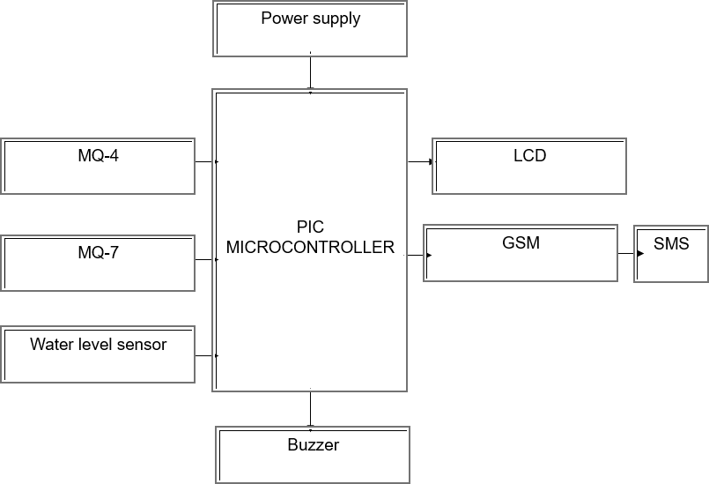

**Fig 2.1:** Block Diagram Of Proposed System

## CHAPTER 3

**HARDWARE AND SOFTWARE REQUIREMENT**

### HARDWARE REQUIREMENTS:

* + - Power Supply
    - Micro Controller - PIC 16F877 A
    - LCD 16x2
    - Level Sensor
    - Temperature Sensor LM-35
    - Gas Sensor (MQ4-Methane, MQ7-Corbon Monoxide)
    - GSM

### SOFTWARE REQUIREMENTS:

* + - MPLAB IDE
    - EMBEDDED C

## HARDWARE DESCRIPTION

### POWER SUPPLY:

A power supply (sometimes known as a power supply unit or PSU) is a device or system that supplies electrical or other types of energy to an output load or group of loads. The term is most commonly applied to electrical energy supplies, less often to mechanical ones, and rarely to others.

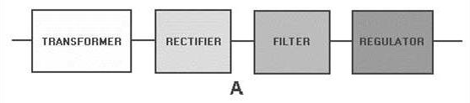

**Fig 3.1**: Power Supply Diagram

## Block diagram of a basic power supply:

The transformer steps up or steps down the input line voltage and isolates the power supply from the power line. The RECTIFIER section converts the alternating current input signal to a pulsating direct current. However, as you proceed in this chapter you will learn that pulsating dc is not desirable. For this reason a FILTER section is used to convert pulsating dc to a purer, more desirable form of dc voltage.

The final section, the REGULATOR, does just what the name implies. It maintains the output of the power supply at a constant level in spite of large changes in load current or input line voltages. Now that you know what each section does, let's trace an ac signal through the power supply. At this point you need to see how this signal is altered within each section of the power supply. Later on in the chapter you will see how these changes take place. In view B of figure 4-1, an input signal of 115 volts ac is applied to the primary of the transformer. The transformer is a step-up transformer with a turns ratio of 1:3. You can calculate the output for this transformer by multiplying the input voltage by the ratio of turns in the primary to the ratio of turns in the secondary; therefore, 115 volts ac ´ 3 = 345 volts ac (peak-to- peak) at the output. Because each diode in the rectifier section conducts for 180 degrees of the 360-degree input, the output of the rectifier will be one-half, or approximately 173 volts of pulsating dc. The filter section, a network of resistors, capacitors, or inductors, controls the rise and fall time of the varying signal; consequently, the signal remains at a more constant dc level. You will see the filter process more clearly in the discussion of the actual filter circuits. The output of the filter is a signal of 110 volts dc, with ac ripple riding on the dc. The reason for the lower voltage (average voltage) will be explained later in this chapter. The regulator maintains

its output at a constant 110-volt dc level, which is used by the electronic equipment (more commonly called the load).

Simple 5V power supply for digital circuits:

* + - * + Brief description of operation: Gives out well regulated +5V output, output current capability of 100 mA
        + Circuit protection: Built-in overheating protection shuts down output when regulator IC gets too hot
        + Circuit complexity: Very simple and easy to build
        + Circuit performance: Very stable +5V output voltage, reliable operation
        + Availability of components: Easy to get, uses only very common basic components
        + Design testing: Based on datasheet example circuit, I have used this circuit successfully as part of many electronics projects
        + Applications: Part of electronics devices, small laboratory power supply
        + Power supply voltage: Unregulated DC 8-18V power supply
        + Power supply current: Needed output current + 5 mA
        + Component costs: Few dollars for the electronics components + the input transformer cost

## CIRCUIT DESCRIPTION:

This circuit is a small +5V power supply, which is useful when experimenting with digital electronics. Small inexpensive wall transformers with variable output voltage are available from any electronics shop and supermarket. Those transformers are easily available, but usually their voltage regulation is very poor, which makes then not very usable for digital circuit experimenter unless a better regulation can be achieved in some way. The following circuit is the answer to the problem.

This circuit can give +5V output at about 150 mA current, but it can be

increased to 1 A when good cooling is added to 7805 regulator chip. The circuit has over overload and thermal protection.

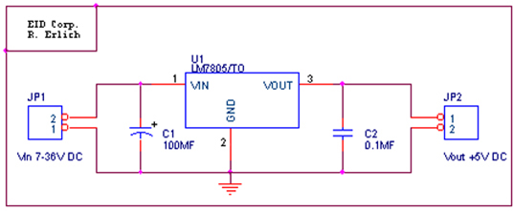

**Fig 3.2**: Circuit Diagram Power Supply 1

## Circuit diagram of the power supply:

The capacitors must have enough high voltage rating to safely handle the input voltage feed to circuit. The circuit is very easy to build for example into a piece of Vero board.

Pinout of the 7805 regulator IC:

* + - * + Unregulated voltage in
        + Ground
        + Regulated voltage out

## Component list:

* + - * + 7805 regulator IC
        + 100 uF electrolytic capacitor, at least 25V voltage rating
        + 10 uF electrolytic capacitor, at least 6V voltage rating
        + 100 nF ceramic or polyester capacitor

## More output current:

If you need more than 150 mA of output current, you can update the

output current up to 1A doing the following modifications:

* + - * + Change the transformer from where you take the power to the circuit to a
        + model which can give as much current as you need from output
        + Put a heat sink to the 7805 regulator (so big that it does not overheat because of the extra losses in the regulator) .

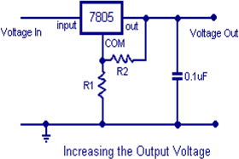

**Fig 3.3**: Circuit Diagram Of Power Supply 2

## PIC 16F877A MICROCONTROLLER:

The PIC microcontroller used here is 16F877A. This performs the key role of processing the received data from the sensors and transmitting them to the Li-Fi module. The advantage of micro controller such as low power consumption and flexibility to connect other devices makes it as the best choice among other processors. The features of this micro controller include the following.

* RISC architecture
* Operating frequency 0-20 MHz
* Power supply voltage 2.0-5.5V
* 8K ROM memory in FLASH technology
* 256 bytes EEPROM memory
* 368 bytes RAM memory
* A/D converter:

1. 14-channels
2. 10-bit resolution

* 3 independent timers/counters
* Watch-dog timer

PIC (usually pronounced as "pick") is a family of microcontrollers made by Microchip Technology, derived from the PIC1650 originally developed by General Instrument's Microelectronics Division. The name PIC initially referred to Peripheral Interface Controller and is currently expanded as Programmable Intelligent Computer. The first parts of the family were available in 1976; by 2013 the company had shipped more than twelve billion individual parts, used in a wide variety of embedded systems.

Early models of PIC had read-only memory (ROM) or field-programmable EPROM for program storage, some with provision for erasing memory. All current models use flash memory for program storage, and newer models allow the PIC to reprogram itself. Program memory and data memory are separated. Data memory is 8-bit, 16-bit, and, in latest models, 32-bit wide. Program instructions vary in bit-count by family of PIC, and may be 12, 14, 16, or 24 bits long. The instruction set also varies by model, with more powerful chips adding instructions for digital signal processing functions.

The hardware capabilities of PIC devices range from 6-pin SMD, 8-pin DIP chips up to 144-pin SMD chips, with discrete I/O pins, ADC and DAC modules, and communications ports such as UART, I2C, CAN, and even USB. Low-power and high-speed variations exist for many types.

The manufacturer supplies computer software for development known as MPLAB X, assemblers and C/C++ compilers, and programmer/debugger hardware under the MPLAB and PIC Kit series. Third party and some open- source tools are also available. Some parts have in-circuit programming

capability; low-cost development programmers are available as well as high- production programmers.

PIC devices are popular with both industrial developers and hobbyists due to their low cost, wide availability, large user base, extensive collection of application notes, and availability of low cost or free development tools, serial programming, and re-programmable flash-memory capability.

### FEATURES:

High-Performance RISC CPU:

* + - * + Only 35 single-word instructions to learn
        + All single-cycle instructions except for program branches, which are two-cycle
        + Operating speed: DC – 20 MHz clock input DC – 200 ns instruction cycle.
        + Up to 8K x 14 words of Flash Program Memory, Up to 368 x 8 bytes of Data Memory (RAM), Up to 256 x 8 bytes of EEPROM Data Memory
        + Pin out compatible to other 28-pin or 40/44-pin PIC16CXXX and PIC16FXXX microcontrollers.

### Peripheral Features:

* + - * + Timer0: 8-bit timer/counter with 8-bit presale
        + Timer1: 16-bit timer/counter with presale, can be incremented during Sleep via external crystal/clock
        + Timer2: 8-bit timer/counter with 8-bit period register, prescaler and postocular

Two Capture, Compare, PWM modules

Capture is 16-bit, max. resolution is 12.5 ns

Compare is 16-bit, max. resolution is 200 ns

* + - * + PWM max. resolution is 10-bit
        + Synchronous Serial Port (SSP) with SPI™ (Master mode) and I2C™ (Master/Slave)
        + Universal Synchronous Asynchronous Receiver Transmitter (USART/SCI) with 9-bit address detection
        + Parallel Slave Port (PSP) – 8 bits wide with external RD, WR and CS controls (40/44-pin only)
        + Brown-out detection circuitry for Brown-out Reset (BOR)

## Analog Features:

* + - * + 10-bit, up to 8-channel Analog-to-Digital Converter (A/D)
        + Brown-out Reset (BOR)
        + Analog Comparator module with:

Two analog comparators

Programmable on-chip voltage reference (VREF) module

Programmable input multiplexing from device inputs and internal voltage reference

Comparator outputs are externally accessible

## Special Micro controller Features:

* + - * + 100,000 erase/write cycle Enhanced Flash program memory typical
        + 1,000,000 erase/write cycle Data EEPROM memory typical
        + Data EEPROM Retention > 40 years
        + Self-re programmable under software control
        + In-Circuit Serial Programming™ (ICSP™) via two pins
        + Single-supply 5V In-Circuit Serial Programming
        + Watchdog Timer (WDT) with its own on-chip RC oscillator for reliable operation
        + Programmable code protection
        + Power saving Sleep mode
        + Selectable oscillator options
        + In-Circuit Debug (ICD) via two pins

## CMOS Technology:

* + - * + Low-power, high-speed Flash/EEPROM technology
        + Fully static design
        + Wide operating voltage range (2.0V to 5.5V)
        + Commercial and Industrial temperature ranges
        + Low-power consumption

## Pin Diagram:

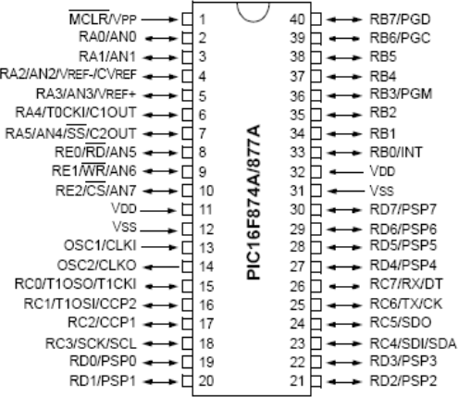

**Fig 3.4:** Pin Diagram Of PIC16F874A/877A

## DEVICE OVERVIEW:

This document contains device specific information about the following devices:

* PIC16F873A
* PIC16F874A
* PIC16F876A
* PIC16F877A

PIC16F873A/876A devices are available only in 28-pin packages, while PIC16F874A/877A devices are available in 40-pin and 44-pin packages. All devices in the PIC16F87XA family share common architecture with the following differences

* + The PIC16F873A and PIC16F874A have one-half of the total on-chip memory of the PIC16F876A and PIC16F877A
  + The 28-pin devices have three I/O ports, while the 40/44-pin devices have five
  + The 28-pin devices have fourteen interrupts, while the 40/44-pin devices have fifteen
  + The 28-pin devices have five A/D input channels, while the 40/44-pin devices have eight
  + The Parallel Slave Port is implemented only on the 40/44-pin devices

The available features are summarized in Table 1-1. Block diagrams of the PIC16F873A/876A and PIC16F874A/877A devices are provided in Figure 1-1 and Figure 1-2, respectively. The pin outs for these device families are listed in Table 1-2 and Table 1-3. Additional information may be found in the PICmicro® Mid-Range Reference Manual (DS33023), which may be obtained from your local Microchip Sales Representative or downloaded from the

Microchip web site. The Reference Manual should be considered a complementary document to this data sheet and is highly recommended reading for a better understanding of the device architecture and operation of the peripheral modules.

## Memory Organization:

There are three memory blocks in each of the PIC16F87XA devices. The program memory and data memory have separate buses so that concurrent access can occur and is detailed in this section. The EEPROM data memory block is detailed in **Section 3.0 “Data EEPROM and Flash Program Memory”**. Additional information on device memory may be found in the PICmicro® Mid-Range MCU Family Reference Manual (DS33023).

### Program Memory Organization.

The PIC16F87XA devices have a 13-bit program counter capable of addressing an 8K word x 14 bit program memory space. The PIC16F876A/877A devices have 8K words x 14 bits of Flash program memory, while PIC16F873A/874A devices have 4K words x 14 bits. Accessing a location above the physically implemented address will cause a wraparound. The Reset vector is at 0000h and the interrupt vector is at 0004h.

## Data Memory Organization:

The data memory is partitioned into multiple banks which contain the General Purpose Registers and the Special Function Registers. Bits RP1 (Status<6>) and RP0 (Status<5>) are the bank select bits. Each bank extends up to 7Fh (128 bytes). The lower locations of each bank are reserved for the Special Function Registers. Above the Special Function Registers are General Purpose Registers, implemented as static RAM. All implemented banks contain

Special Function Registers. Some frequently used Special Function Registers from one bank may be mirrored in another bank for code reduction and quicker access.

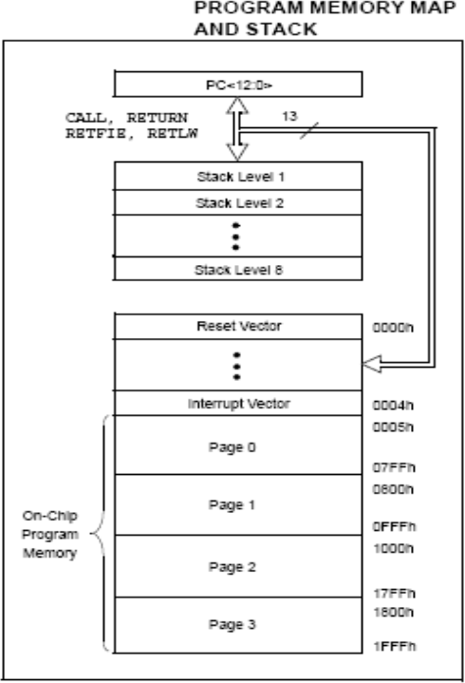

**Fig 3.5:** Program Memory Map And Stack Diagram

## I/O PORTS:

Some pins for these I/O ports are multiplexed with an alternate function for the peripheral features on the device. In general, when a peripheral is enabled, that pin may not be used as a general purpose I/O pin. Additional

information on I/O ports may be found in the Pismire™ Mid-Range Reference Manual (DS33023).

## PORTA and the TRISA Register:

PORTA is a 6-bit wide, bidirectional port. The corresponding data direction register is TRISA. Setting a TRISA bit (= 1) will make the corresponding PORTA pin an input (i.e., put the corresponding output driver in a High-Impedance mode). Clearing a TRISA bit (= 0) will make the corresponding PORTA pin an output (i.e., put the contents of the output latch on the selected pin). Reading the PORTA register reads the status of the pins, whereas writing to it will write to the port latch. All write operations are read- modify-write operations. Therefore, a write to a port implies that the port pins are read; the value is modified and then written to the port data latch. Pin RA4 is multiplexed with the Timer0 module clock input to become the RA4/T0CKI pin. The RA4/T0CKI pin is a Schmitt Trigger input and an open-drain output. All other PORTA pins have TTL input levels and full CMOS output drivers. Other PORTA pins are multiplexed with analog inputs and the analog VREF input for both the A/D converters and the comparators. The operation of each pin is selected by clearing/setting the appropriate control bits in the ADCON1 and/or CMCON registers. The TRISA register controls the direction of the port pins even when they are being used as analog inputs. The user must ensure the bits in the TRISA register are maintained set when using them as analog inputs.

## PORTB and the TRISB Register:

PORTB is an 8-bit wide, bidirectional port. The corresponding data direction register is TRISB. Setting a TRISB bit (= 1) will make the corresponding PORTB pin an input (i.e., put the corresponding output driver in a High-Impedance mode). Clearing a TRISB bit (= 0) will make the

corresponding PORTB pin an output (i.e., put the contents of the output latch on the selected pin). Three pins of PORTB are multiplexed with the In-Circuit

Debugger and Low-Voltage Programming function: RB3/PGM, RB6/PGC and RB7/PGD. The alternate functions of these pins are described in **“Special Features of the CPU”**. Each of the PORTB pins has a weak internal pull-up. A single control bit can turn on all the pull-ups. This is performed by clearing bit RBPU (OPTION_REG<7>). The weak pull-up is automatically turned off when the port pin is configured as an output. The pull-ups are disabled on a Power-on Reset.

This interrupt can wake the device from Sleep. The user, in the Interrupt Service Routine, can clear the interrupt in the following manner:

1. Any read or write of PORTB. This will end the mismatch condition.
2. Clear flag bit RBIF.

A mismatch condition will continue to set flag bit RBIF. Reading PORTB will end the mismatch condition and allow flag bit RBIF to be cleared. The interrupt-on-change feature is recommended for wake-up on key depression operation and operations where PORTB is only used for the interrupt-on-change feature. Polling of PORTB is not recommended while using the interrupt-on- change feature. This interrupt-on-mismatch feature, together with software configurable pull-ups on these four pins, allow easy interface to a keypad and make it possible for wake-up on key depression.

## 3.1.1.13 PORTC and the TRISC Register:

PORTC is an 8-bit wide, bidirectional port. The corresponding data direction register is TRISC. Setting a TRISC bit (= 1) will make the corresponding PORTC pin an input (i.e., put the corresponding output driver in a High-Impedance mode). Clearing a TRISC bit (= 0) will make the corresponding PORTC pin an output (i.e., put the contents of the output latch on

the selected pin). PORTC is multiplexed with several peripheral functions (Table 4-5). PORTC pins have Schmitt Trigger input buffers. When the I2C module is enabled, the PORTC<4:3> pins can be configured with normal I2C levels, or with SMBus levels, by using the CKE bit (SSPSTAT<6>).

When enabling peripheral functions, care should be taken in defining TRIS bits for each PORTC pin. Some peripherals override the TRIS bit to make a pin an output, while other peripherals override the TRIS bit to make a pin an input. Since the TRIS bit override is in effect while the peripheral is enabled, read- modify write instructions (BSF, BCF, and XORWF) with TRISC as the destination, should be avoided. The user should refer to the corresponding peripheral section for the correct TRIS bit settings.

## PORTD and TRISD Registers:

PORTD is an 8-bit port with Schmitt Trigger input buffers. Each pin is individually configurable as an input or output. PORTD can be configured as an 8-bit wide microprocessor port (Parallel Slave Port) by setting control bit, PSPMODE (TRISE<4>). In this mode, the input buffers are TTL.

## PORTD Functions:

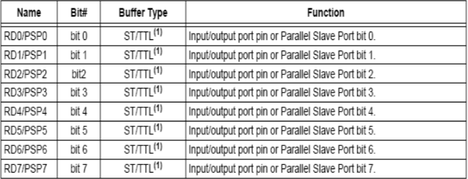

**Table 3.1**: Port Functions

## PORTE and TRISE Register:

PORTE has three pins (RE0/RD/AN5, RE1/WR/AN6 and RE2/CS/AN7) which are individually configurable as inputs or outputs. These pins have Schmitt Trigger input buffers. The PORTE pins become the I/O control inputs for the microprocessor port when bit PSPMODE (TRISE<4>) is set. In this mode, the user must make certain that the TRISE<2:0> bits are set and that the pins are configured as digital inputs. Also, ensure that ADCON1 is configured for digital I/O. In this mode, the input buffers are TTL.

Register 4-1 shows the TRISE register which also controls the Parallel Slave Port operation. PORTE pins are multiplexed with analog inputs. When selected for analog input, these pins will read as ‘0’s. TRISE controls the direction of the RE pins, even when they are being used as analog inputs. The user must make sure to keep the pins configured as inputs when using them as analog inputs.

## 3.1.3 16×2 LCD:

LCD stands for liquid crystal display. They come in many sizes 8x1 , 8x2

, 10x2 , 16x1 , 16x2 , 16x4 , 20x2 , 20x4 ,24x2 , 30x2 , 32x2 , 40x2 etc . Many

multinational companies like Philips Hitachi Panasonic make their own special kind of LCD'S to be used in their products. All the LCD'S performs the same functions (display characters numbers special characters ASCII characters etc).Their programming is also same and they all have same 14 pins (0-13) or

16 pins (0 to 15). Alphanumeric displays are used in a wide range of applications, including palmtop computers, word processors, photocopiers, point of sale terminals, medical instruments, cellular phones, etc.

## PRODUCT DESCRIPTION:

This is an LCD Display designed for E-blocks. It is a 16 character, 2- line alphanumeric LCD display connected to a single 9-way D-type connector. This allows the device to be connected to most E-Block I/O ports. The LCD display requires data in a serial format, which is detailed in the user guide below. The display also requires a 5V power supply. Please take care not to exceed 5V, as this will cause damage to the device. The 5V is best generated from the E-blocks Multi programmer or a 5V fixed regulated power supply.

The 16 x 2 intelligent alphanumeric dot matrix displays is capable of displaying 224 different characters and symbols. A full list of the characters and symbols is printed on pages 7/8 (note these symbols can vary between brand of LCD used). This booklet provides all the technical specifications for connecting the unit, which requires a single power supply (+5V).

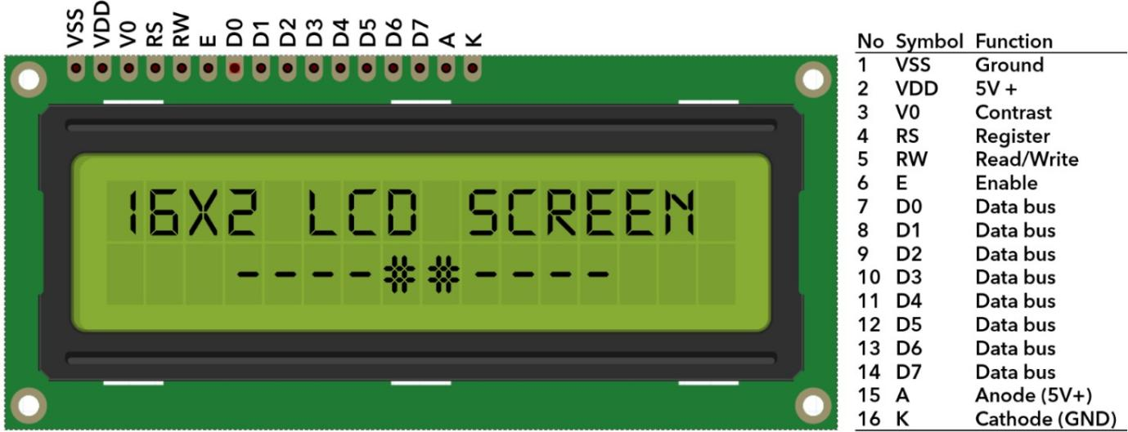

**Fig 3.6:** 16x2 LCD Display

## FEATURES:

* + - * + Input voltage: 5v
        + E-blocks compatible
        + Low cost
        + Compatible with most I/O ports in the E-Block range
        + Ease to develop programming code using Flow code

## TEMPERATURE SENSOR:

The LM35 series are precision integrated-circuit temperature devices with an output voltage linearly proportional to the Centigrade temperature. The LM35 device has an advantage over linear temperature sensors calibrated in Kelvin, as the user is not required to subtract a large constant voltage from the output to obtain convenient Centigrade scaling. The LM35 device does not require any external calibration or trimming to provide typical accuracies of

±¼°C at room temperature and ±¾°C over a full −55°C to 150°C temperature range. The low-output impedance, linear output, and precise inherent calibration of the LM35 device makes interfacing to readout or control circuitry especially easy.

## PRODUCT DESCRIPTION:

LM35 is a precision IC temperature sensor with its output proportional to the temperature (in oC). The sensor circuitry is sealed and therefore it is not subjected to oxidation and other processes. With LM35, temperature can be measured more accurately than with a thermistor. It also possess low self heating and does not cause more than 0.1 oC temperature rise in still air. The device is used with single power supplies, or with plus and minus supplies. As the LM35 device draws only 60 µA from the supply, it has very low self-heating of less than 0.1°C in still air. The LM35 device is rated to operate over a −55°C to 150°C temperature range.

## FEATURES:

1. Calibrated Directly in Celsius (Centigrade)
2. Linear + 10-mV/°C Scale Factor
3. 0.5°C Ensured Accuracy (at 25°C)
4. Rated for Full −55°C to 150°C Range
5. Suitable for Remote Applications

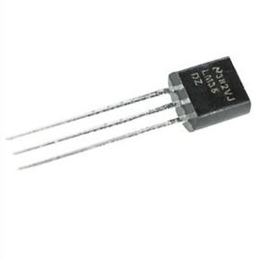

**Fig 3.7:** Temperature Sensor

## : APPLICATIONS:

1. Power Supplies
2. Battery Management
3. HVAC
4. Appliances

## GAS SENSOR:

In current technology scenario, monitoring of gases produced is very important. From home appliances such as air conditioners to electric chimneys and safety systems at industries monitoring of gases is very crucial. Gas sensors spontaneously react to the gas present, thus keeping the system updated about any alterations that occur in the concentration of molecules at gaseous state. The gas sensor module consists of a steel exoskeleton under which a sensing element is housed. This sensing element is subjected to current through connecting leads. This current is known as heating current through it, the gases coming close to the sensing element get ionized and are absorbed by the sensing

element. This changes the resistance of the sensing element which alters the value of the current going out of it. The connecting leads of the sensor are thick so that sensor can be connected firmly to the circuit and sufficient amount of heat gets conducted to the inside part. They are casted from copper and have tin plating over them.

## PRODUCT DESCRIPTION:

Gas sensor is designed with sensitive material of sno2, which with lower conductivity in clean air. When the target combustible gas exists, the sensor’s conductivity is higher. Signal conditioning circuit is used to convert the change of conductivity to correspond output signal with the input gas concentration. Gas sensor has high sensitivity to LPG, Propane and Hydrogen, also could be used to Methane and other combustible steam, it is with low cost and suitable for different application. The gas module is mounted on a pub board which has an operating voltage of 5VDC. The sensor output values can be getting by means of both analogy and digital.

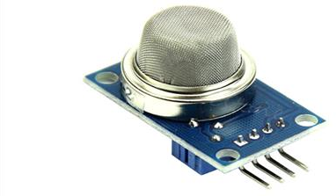

**Fig 3.8:** Gas Sensor

## FEATURES

* Analog and Digital output
* Good sensitivity to Combustible gas in wide range
* High sensitivity to LPG, Propane and Hydrogen
* Operation voltage: 5VDC
* Simple drive circuit
* Long life and low cost

## APPLICATIONS:

* Domestic gas leakage detector
* Industrial Combustible gas detector
* Portable gas detector

## GSM

SIM Com Wireless Solutions is a subsidiary of SIM Technology Group Ltd (stock code: 2000. H.K). It is a fast-growing wireless M2M company, designing and offering a variety of wireless modules based on GSM/GPRS/EDGE, WCDMA/HSDPA and TD-SCDMA technical platforms By partnering with third parties, SIM Com Wireless provides customized design solutions in M2M, WLL, Mobile Computing, GPS and other applications. SIM Com Wireless also provides ODM services for customers. According to ABI Insight report, SIM Com Cellular Module was number two provider of wireless modules worldwide in 2008 with 20% acquisition of global market share.

## PRODUCT DESCRIPTION :

This GSM Modem can accept any GSM network act as SIM card and just like a mobile phone with its own unique phone number. Advantage of using this modem will be that you can use its RS232 port to communicate and develop embedded applications. The SIM900A is a complete Dual-band GSM/GPRS solution in a SMT module featuring an industry-standard interface; the SIM800 delivers GSM/GPRS 900/1800MHz performance for voice, SMS, Data, and Fax in a small form factor and with low power consumption. With a tiny configuration of 24mm x 24mm x 3 mm, SIM800

can fit almost all the space requirements in your applications, especially for slim and compact demand of design.

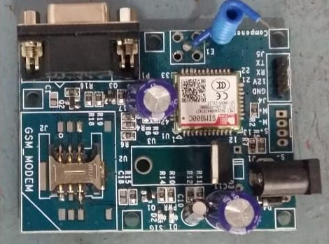

**Fig 3.9:** GSM

## FEATURES

* + - * + High Quality Product
        + RS232 interface @ RMC Connector for direct communication with computer or MCU kit
        + Configurable baud rate
        + SMA connector with GSM Antenna.
        + SIM Card holder.
        + Built in Network Status LED
        + Inbuilt Powerful TCP/IP protocol stack for internet data transfer over GPRS.
        + Audio interface Connector
        + Normal operation temperature: -20 °C to +55 °C
        + Input Voltage: 4.5V-12V DC

## APPLICATIONS

* + - * + Short Message Service(SMS)
        + Internet
        + Incoming /outgoing calls

## SOFTWARE DESCRIPTION:

* + 1. **MP LAB:**

MPLAB is a proprietary freeware integrated development environment for the development of embedded applications on PIC and dsPIC microcontrollers, and is developed by Microchip Technology. MPLAB and MPLAB X support project management, code editing, debugging and programming of Microchip 8-bit PIC and AVR (including ATMEGA) microcontrollers, 16-bit PIC24 and dsPIC microcontrollers, as well as 32-bit SAM (ARM) and PIC32 (MIPS) microcontrollers.

MPLAB is designed to work with MPLAB-certified devices such as the MPLAB ICD 3 and MPLAB REAL ICE, for programming and debugging PIC microcontrollers using a personal computer. PICKit programmers are also supported by MPLAB.

MPLAB X supports automatic code generation with the MPLAB Code Configurator and the MPLAB Harmony Configurator plugins.

Early models of PIC had read-only memory (ROM) or field- programmable EPROM for program storage, some with provision for erasing memory. All current models use flash memory for program storage, and newer models allow the PIC to reprogram itself. Program memory and data memory are separated. Data memory is 8-bit, 16-bit, and, in latest models, 32-bit wide. Program instructions vary in bit-count by family of PIC, and may be 12, 14, 16, or 24 bits long. The instruction set also varies by model, with more powerful chips adding instructions for digital signal processing functions.

The hardware capabilities of PIC devices range from 6-pin SMD, 8-pin DIP chips up to 144-pin SMD chips, with discrete I/O pins, ADC and DAC modules, and communications ports such as UART, I2C, CAN, and even USB. Low-power and high-speed variations exist for many types.

The manufacturer supplies computer software for development known as MPLAB X, assemblers and C/C++ compilers, and programmer/debugger

hardware under the MPLAB and PICKit series. Third party and some open- source tools are also available. Some parts have in-circuit programming capability; low-cost development programmers are available as well as high- production programmers.

PIC devices are popular with both industrial developers and hobbyists due to their low cost, wide availability, large user base, extensive collection of application notes, availability of low cost or free development tools, serial programming, and re-programmable Flash-memory capability.

## EMBEDDED C:

Embedded C is a set of language extensions for the C programming language by the C Standards Committee to address commonality issues that exist between C extensions for different embedded systems.

Historically, embedded C programming requires nonstandard extensions to the C language in order to support exotic features such as fixed-point arithmetic, multiple distinct memory banks, and basic I/O operations. In 2008, the C Standards Committee extended the C language to address these issues by providing a common standard for all implementations to adhere to. It includes a number of features not available in normal C, such as fixed-point arithmetic, named address spaces and basic I/O hardware addressing. Embedded C uses most of the syntax and semantics of standard C, e.g., main () function, variable definition, data type declaration, conditional statements (if, switch case), loops (while, for), functions, arrays and strings, structures and union, bit operations, macros, etc.

## CHAPTER 4 RESULT AND DISCUSSION

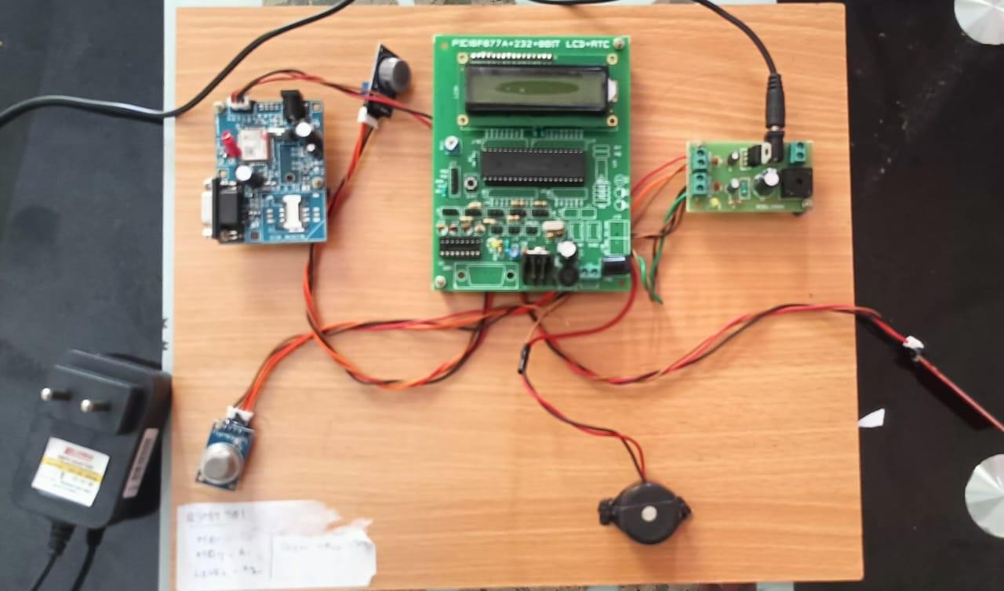

**Fig 4.1:** Kit Output

A modern system that manages the waste water and sewage systems of a city or community with cutting-edge technology and creative methods is known as a smart sewage system. A smart sewage system's major objective is to boost sewage management's effectiveness, dependability, and safety while lessening its negative effects on the environment.

Sensors (MQ-4,MQ-7,Water Level Sensor), data analytic, and other digital technologies that offer real-time information about the sewage system's performance are often used in smart sewage systems. Utilizing this data will improve treatment procedures, cut down on energy use, and detect and stop sewer overflows.

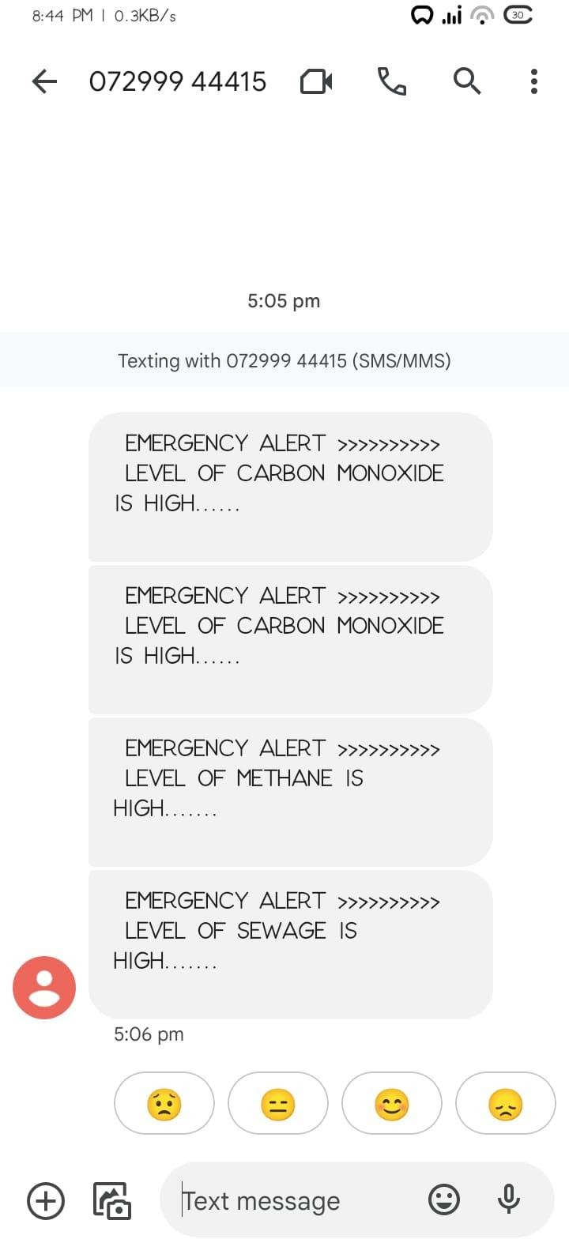

**Fig 4.2:** Smart Sewage System GSM Notification

A smart sewage system with GSM notification is a system that employs GSM (Global System for Mobile Communications) technology to alert specified individuals in real-time when particular sewage system events take place.

For instance, when the sewage system is at capacity, the system's sensors can identify this and send a message through SMS or email to the appropriate staff. This alert enables the staff to respond appropriately, such as scheduling maintenance or diverting the flow of sewage to prevent overflow.

## CHAPTER 5 CONCLUSION

This technology was developed with the goal of measuring critical parameters that must be tracked to ensure the sewage employees' security at all times. The gadget is most useful in residential drainage systems, municipal drainage channels and sewage systems, sewers, deep wells, gutters, drains, etc. Human employees should never come into direct contact with harmful gases or vapours. When compared to other forms of safety devices, the drainage system is both effective and inexpensive. As human labour accounts for the vast majority of sewage cleaning in India, this tool will be particularly welcome there. To combat the issue of sewages, a method was developed to facilitate easier draining and cleaning procedures. This technique smart sewages safety system is unique compared to others that help fix the drainage issue. Level, an emergency button, and potentially harmful gases are just a few of the features of this system. In Future this device will send us real-time alerts via SMS and the Iot website before the drainage overflows, helping both manual scavengers and the physically challenged people . In order to determine how high the sewage water level is, a Level Sensor is used. Because of the dangers associated with exposure to toxic gases, this technology was developed to constantly monitor the gas threshold by linking the level sensor and gas sensors. Future iterations of this technology may also be used to dispose of harmful gases produced within a drainage system.

## CHAPPTER 6 FUTURE SCOPE

Utilising cutting-edge technologies like the Internet of Things (IoT), sensors, and big data analytics in the design and implementation of a smart sewage system will increase the effectiveness of sewage systems. The procedures that can be used to plan and put into place a smart sewage system are as follows.

## Future Aims:

 Smart sewage systems have a very broad future potential. Here are some areas that could use improvement:

 Artificial intelligence (AI): Using AI to analyse data can assist discover trends and foresee prospective sewage system problems.

 Blockchain: The development of a safe and open sewage data management system is possible using blockchain technology.

 Smart sewage systems can produce renewable energy by utilising the sewage as a source of biogas.

 Better Water Management: Smart sewage systems can help improve water management by locating water wasters and enhancing water re-use.

 Smart Cities: The incorporation of smart sewage systems into smart city efforts can help to build more sustainable and effective cities.

## REFERENCE

1. Ajitesh Kumar et.al(2022), "Real-Time Commuincation based IoT enabled Smart Sewage Workers Safety Monitoring System", Published in: 2021 5th International Conference on Information Systems and Computer Networks (ISCON), IEEE Xplore 2022
2. Hamid Raeisi Vanani1, Mohammad Shayannejad1, Ali Reza Soltani Toudeshki1, Mohammad Ali Arab1, Saeid Eslamian1, Vijay P. Singh2, Kaveh Ostad-Ali-Askari. (2018). ”Feasibility Study for Improving the Quality of Refined Sewage Due to the Advancement of Soil.” Water EngineeringDepartment, Isfahan University of Technology, Isfahan, Iran. Department of Biological and Agricultural Engineering Zachry Department of Civil Engineering,Texas A and M University, 321 Scoates Hall, 2117 TAMU, College Station, Texas, U.S.A.
3. Fioccola, G. B., Sommese, R., Tufano, I., Canonico, R., and Ventre, G. (2016).“Polluino: An efficient cloud based management of IoT devices for air quality monitoring.” 2016 IEEE 2nd International Forum on Research and Technologies for Society and Industry Leveraging a better tomorrow (RTSI), 1– 6 (Sep.).
4. Nitin Asthana, Ridhima Bahl. “IoT Device for Sewage Gas Monitoring and Alert System”.
5. Liu, Z., Wang, Z., Chen, R., and Wu, X. (2008). “Intelligent residential security alarm and remote control system based on single chip computer.”2008 3rd IEEE Conference on Industrial Electronics and Applications, 159–161 (June).
6. Prof Muragesh SK1, Santhosha Rao2, “Automated Internet of Things For Underground Drainage and Manhole Monitoring Systems For Metropolitan Cities.” InternationalJournal of Innovative Science, Engineering Technology, Vol. 2 Issue 4, June 2015.
7. Hamzeh Al Zabadi, Luc Ferrari, Irene Sari-Minodier, ´ Marie-Aude Kerautret, Aziz Tiberguent, Christophe Paris, Denis Zmirou-Navier, ”Integrated Exposure Assessment of Sewage Workers to Genotoxicants: an Urinary Biomarker Approach and Oxidative Stress Evaluation”, Environmental Health Journal, March 2011.
8. Vijayalakshmi, R., Dr.Sengeni, D.,”IoT Based Smart Detection System for Harmful Gases in Underground Sewages,” International Journal for Research in Applied Science & Engineering Technology, 5(11), November, 2017.
9. S. Himanshu et.al (2022), "IOT based Manhole Detection and Monitoring System",International Journal for Research in Applied Science & Engineering Technology (IJRASET) ISSN: 2321-9653; IC Value: 45.98; SJ Impact Factor:

7.538 Volume 10 Issue VI June 2022.

1. Asthana, Nitin; Bahl, Ridhima (2019). [IEEE 2019 1st International Conference on Innovations in Information and Communication Technology (ICIICT) - CHENNAI, India (2019.4.25-2019.4.26)] 2019 1st International

Conference on Innovations in Information and Communication Technology (ICIICT) - IoT Device For Sewage Gas Monitoring And Alert System. , (), 1–7. doi:10.1109/ICIICT1.2019.8741423

1. Gopavanitha, K. and Nagaraju, S. (2017). “A low cost system for real time wa-ter quality monitoring and controlling using iot.”2017 International Conference onEnergy, Communication, Data Analytics and Soft Computing (ICECDS), 3227–3229(Aug).
2. Keshamoni, K. and Hemanth, S. (2017). “Smart gas level monitoring, bookingamp;amp; gas leakage detector over iot.”2017 IEEE.